Text Palette
This palette deals with the many aspects of text within Noteflight. A number of kinds of text can be added to Noteflight scores: general text, lyrics, dynamics/expression text and chord symbols.
Tutorial Video

text:

LyricsCtrl+L
Add lyrics to the first selected note in a score. When editing lyrics, a blinking cursor appears in the place where the lyric syllable should go, and you can type the lyric there:
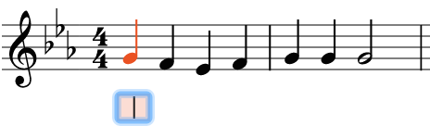
When you are finished typing the syllable, type one of these characters:
- Space finishes this syllable and begins the first syllable of a new word on the following note.
- - (hyphen) finishes this syllable, and continues the current word on a new syllable under the following note, with a dash between the syllables.
- _ (underscore) finishes this word, and shows a extension line to the right of it. Use this when a syllable is sung over several tied or slurred notes; you can press _ multiple times to continue the extension line for as many notes as you like.
- Enter/Return finishes this syllable and begins the lyric for a new verse on the same note.
- Esc finishes this syllable and stops editing lyrics.
As you type, lyrics will be added and the cursor will advance from note to note:
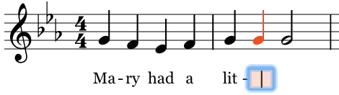
Double-clicking an existing lyric syllable allows you to edit that syllable.
It's easiest to enter one verse of lyrics at a time. To enter subsequent verses of lyrics, double-click the syllable where you want to start and hit Enter. A new verse will be started on that syllable:
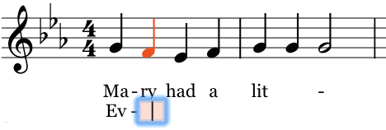
Here is an example showing lyrics with both hyphens and extensions:
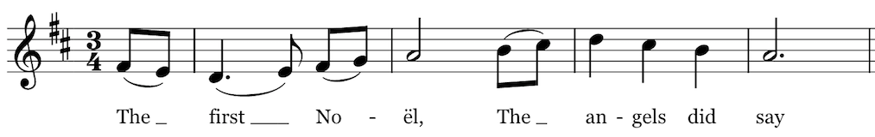
The appearance of hyphens between syllables can be controlled by settings in Formatting Settings; Noteflight can automatically place multiple hyphens between syllables, since sometimes syllables will be spaced out over many intervening notes.

